VISA DLL issue in Latte GUIs

* The absence or improper installation of VISA DLL and related driver files may render the GUI unable to communicate with the EVM.
* When opening the GUI, an error message related to “Visa” or “Visa32” will appear in the logs section of latte like below (Error may not be exactly same).

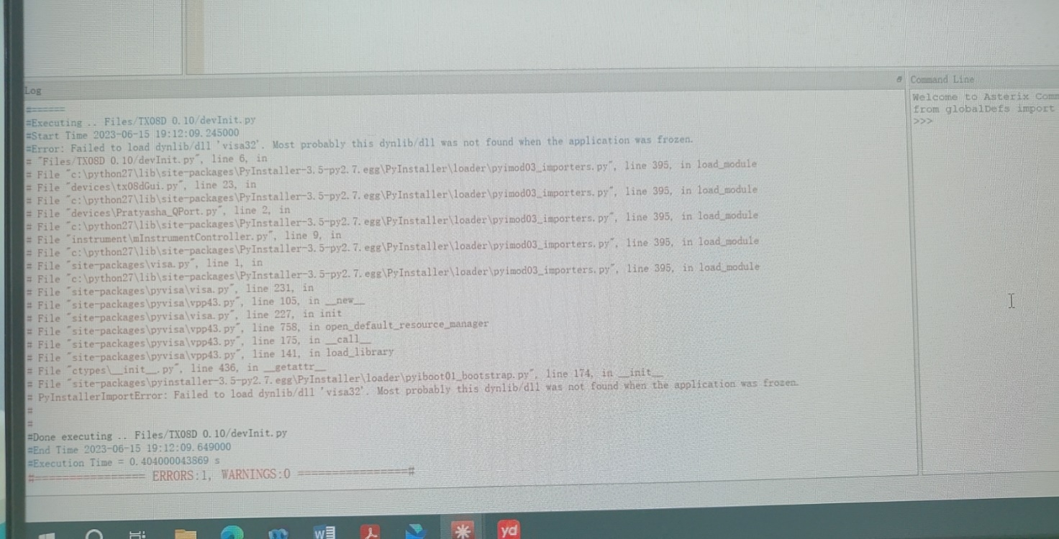

* If the issue is only the absence of visa DLL files, you can try the following solution and it should work:
  + Close the GUI completely
  + Paste the Visa dll files in **install_dir\bin** folder and **C:\Windows\System32**
  + Open the GUI again.



* If the above method did not resolve the issue, please try downloading and installing the NI-Visa software from the below official link after closing the GUI:
  + <https://www.ni.com/en/support/downloads/drivers/download.ni-visa.html>
  + After installing, open the GUI again